NAMA : RANDU ALAMSYAH
KELAS : XI RPL 1

E-Commerce Penjualan Laptop
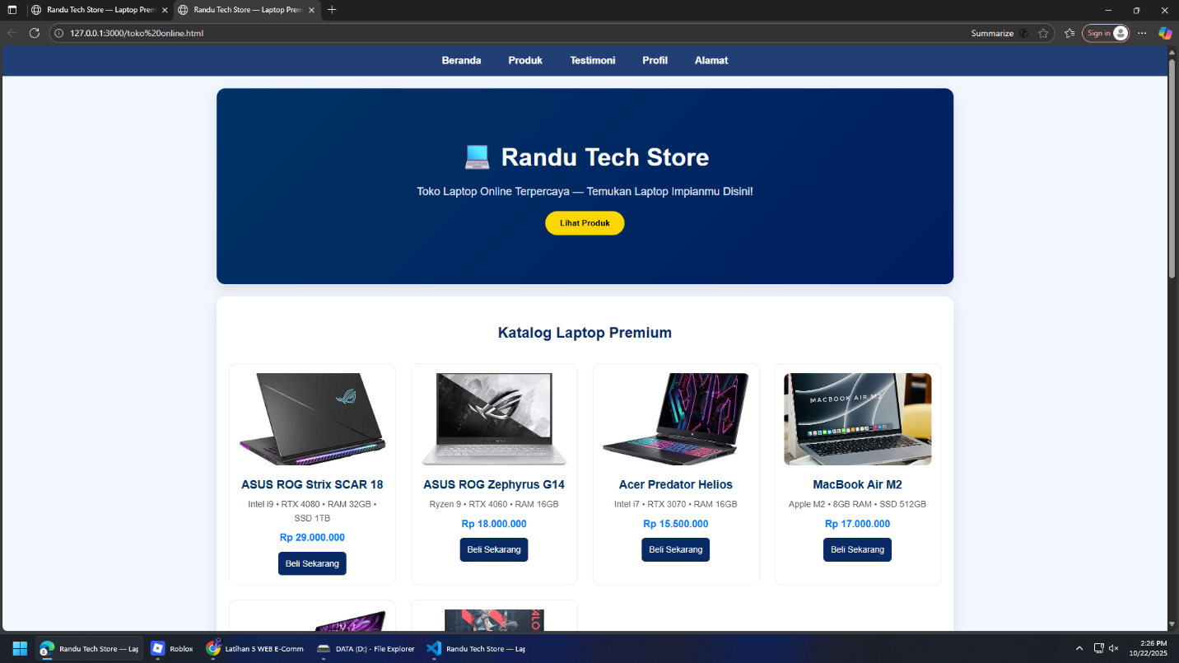
- Berikut Tambpilah hasil Website Ecommerce Tokoh Lapto

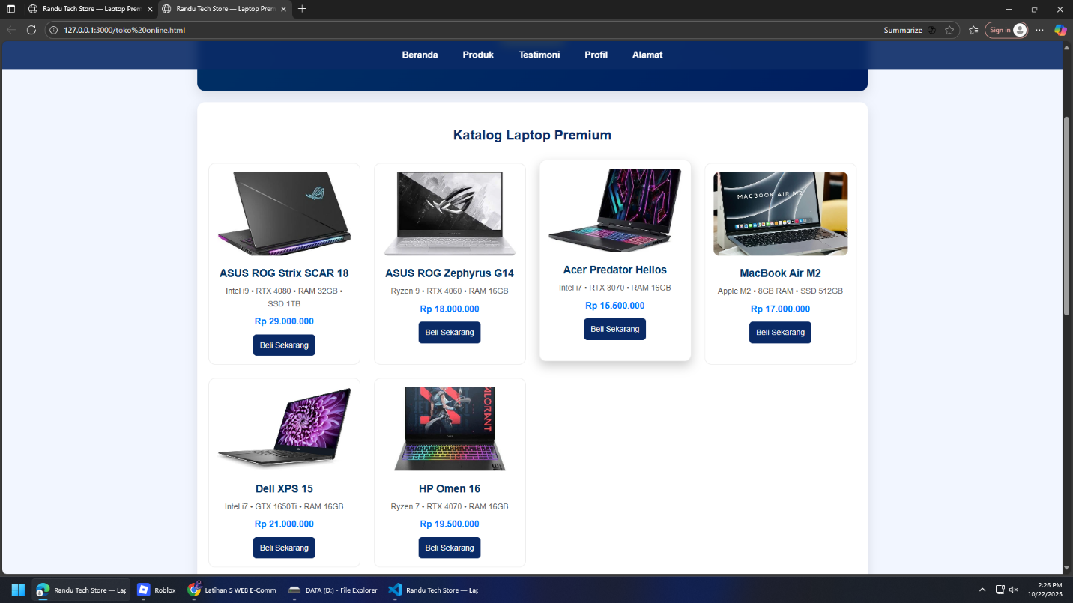
- Berikut Tampilan Hasil Harga Laptop:

- Berikut Tampilan Hasil Profil Penjual :
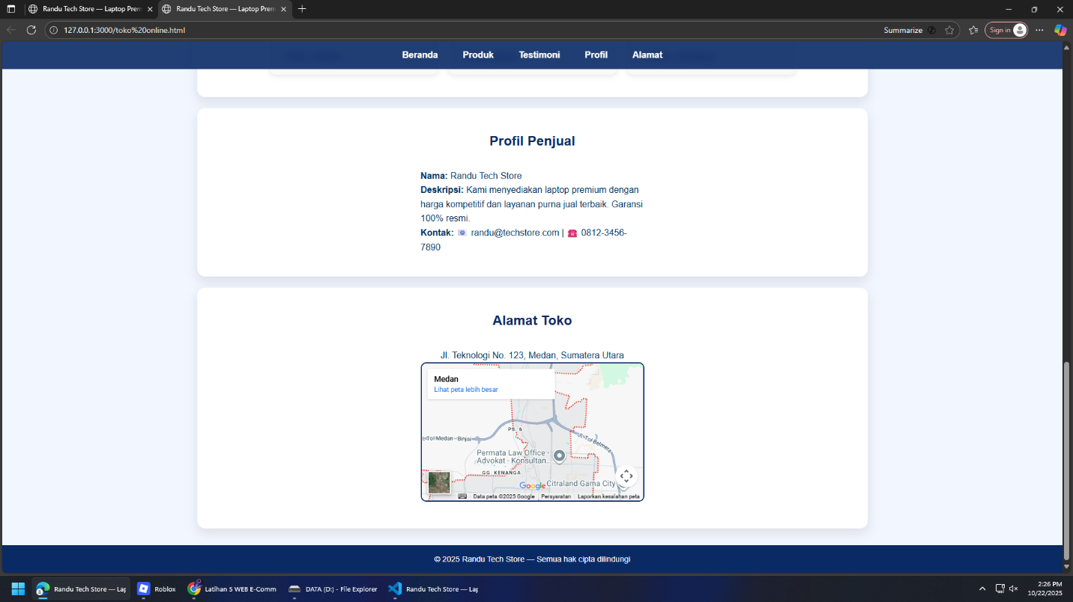

- Berikut Lampirkan Hasil Kodingnya:
<!DOCTYPE html>
<html lang="id">
<head>
<meta charset="UTF-8">
<meta name="viewport" content="width=device-width, initial-scale=1.0">
<title>Randu Tech Store — Laptop Premium Online</title>
<style>
:root {
--primary: #0a2a66;
--secondary: #0078ff;
--accent: #ffd700;
--bg: #f2f6ff;
--card: #ffffff;
--text: #003366;
}
* {box-sizing:border-box;margin:0;padding:0;}
body {
font-family: 'Poppins', sans-serif;
background-color: var(--bg);
color: var(--text);
line-height: 1.6;
scroll-behavior: smooth;
}

/* ===== NAVBAR ===== */
nav {
position: sticky;
top: 0;
background: rgba(10,42,102,0.9);
backdrop-filter: blur(8px);
color: white;
padding: 12px 0;
z-index: 1000;
transition: background 0.3s;
text-align:center;
}
nav a {
color: white;
text-decoration: none;
margin: 0 20px;
font-weight: 600;
transition: color 0.3s;
}
nav a:hover {
color: var(--accent);
}

/* ===== HERO ===== */
.hero {
background: linear-gradient(135deg, #003366, #001e5f);
color: white;
padding: 80px 20px;
text-align: center;
}
.hero h1 {
font-size: 40px;
margin-bottom: 10px;
}
.hero p {
font-size: 18px;
color: #e0e9ff;
}
.hero button {
background: var(--accent);
border: none;
padding: 12px 24px;
border-radius: 30px;
font-weight: bold;
cursor: pointer;
margin-top: 18px;
transition: 0.3s;
}
.hero button:hover {
background: #ffc400;
transform: translateY(-3px);
}

/* ===== PRODUK ===== */
section {
padding: 40px 20px;
margin: 20px auto;
max-width: 1200px;
background: var(--card);
border-radius: 14px;
box-shadow: 0 8px 20px rgba(0,0,0,0.1);
}
h2 {
text-align: center;
color: var(--primary);
margin-bottom: 30px;
}
.gallery {
display: grid;
grid-template-columns: repeat(auto-fit, minmax(220px, 1fr));
gap: 24px;
}
.product-card {
background: #fff;
border-radius: 12px;
padding: 15px;
text-align: center;
transition: transform 0.3s, box-shadow 0.3s;
border: 1px solid #eee;
}
.product-card:hover {
transform: translateY(-6px);
box-shadow: 0 8px 20px rgba(0,0,0,0.2);
}
.product-card img {
width: 100%;
height: 150px;
object-fit: cover;
border-radius: 10px;
}
.product-card h3 {
margin: 10px 0 5px;
}
.product-card p {
font-size: 14px;
color: #555;
margin-bottom: 8px;
}
.price {
font-weight: bold;
color: var(--secondary);
font-size: 16px;
}
.btn {
display: inline-block;
margin-top: 10px;
padding: 8px 12px;
border-radius: 6px;
text-decoration: none;
font-size: 14px;
color: white;
background: var(--primary);
transition: 0.3s;
}
.btn:hover {background: var(--secondary);}

/* ===== TESTIMONI ===== */
.testimoni {
display: flex;
flex-wrap: wrap;
justify-content: center;
gap: 20px;
}
.testimoni .card {
background: #f9f9f9;
border-radius: 10px;
padding: 20px;
width: 300px;
box-shadow: 0 2px 10px rgba(0,0,0,0.1);
}
.testimoni .card p {
font-style: italic;
color: #333;
}
.testimoni .card span {
display: block;
margin-top: 10px;
color: var(--primary);
font-weight: bold;
}

/* ===== PROFIL & MAP ===== */
.profile {
display: flex;
align-items: center;
justify-content: center;
gap: 20px;
flex-wrap: wrap;
}
.profile img {
width: 140px;
border-radius: 50%;
border: 3px solid var(--primary);
}
.profile-info {max-width: 400px;text-align: left;}
iframe {border-radius: 10px;border: 2px solid var(--primary);}

/* ===== FOOTER ===== */
footer {
background: var(--primary);
color: white;
text-align: center;
padding: 14px;
font-size: 14px;
margin-top: 30px;
}
</style>
</head>
<body>

<nav>
<a href="#home">Beranda</a>
<a href="#produk">Produk</a>
<a href="#testimoni">Testimoni</a>
<a href="#profil">Profil</a>
<a href="#alamat">Alamat</a>
</nav>

<section class="hero" id="home">
<h1>💻 Randu Tech Store</h1>
<p>Toko Laptop Online Terpercaya — Temukan Laptop Impianmu Disini!</p>
<button onclick="window.location.href='#produk'">Lihat Produk</button>
</section>

<section id="produk">
<h2>Katalog Laptop Premium</h2>
<div class="gallery">
<div class="product-card">
<img src="https://images.unsplash.com/photo-1587202372775-98927f989ca1?auto=format&fit=crop&w=800&q=60" alt="ASUS ROG Strix">
<h3>ASUS ROG Strix SCAR 18</h3>
<p>Intel i9 • RTX 4080 • RAM 32GB • SSD 1TB</p>
<div class="price">Rp 29.000.000</div>
<a href="#" class="btn">Beli Sekarang</a>
</div>

<div class="product-card">
<img src="https://images.unsplash.com/photo-1509395176047-4a66953fd231?auto=format&fit=crop&w=800&q=60" alt="ASUS Zephyrus">
<h3>ASUS ROG Zephyrus G14</h3>
<p>Ryzen 9 • RTX 4060 • RAM 16GB</p>
<div class="price">Rp 18.000.000</div>
<a href="#" class="btn">Beli Sekarang</a>
</div>

<div class="product-card">
<img src="https://images.unsplash.com/photo-1587206666240-95b69f0c2956?auto=format&fit=crop&w=800&q=60" alt="Acer Predator">
<h3>Acer Predator Helios</h3>
<p>Intel i7 • RTX 3070 • RAM 16GB</p>
<div class="price">Rp 15.500.000</div>
<a href="#" class="btn">Beli Sekarang</a>
</div>

<div class="product-card">
<img src="https://images.unsplash.com/photo-1593642634367-d91a135587b5?auto=format&fit=crop&w=800&q=60" alt="MacBook Air M2">
<h3>MacBook Air M2</h3>
<p>Apple M2 • 8GB RAM • SSD 512GB</p>
<div class="price">Rp 17.000.000</div>
<a href="#" class="btn">Beli Sekarang</a>
</div>

<div class="product-card">
<img src="https://images.unsplash.com/photo-1587206666240-95b69f0c2956?auto=format&fit=crop&w=800&q=60" alt="Dell XPS">
<h3>Dell XPS 15</h3>
<p>Intel i7 • GTX 1650Ti • RAM 16GB</p>
<div class="price">Rp 21.000.000</div>
<a href="#" class="btn">Beli Sekarang</a>
</div>

<div class="product-card">
<img src="https://images.unsplash.com/photo-1602080877944-1465a54e7c8e?auto=format&fit=crop&w=800&q=60" alt="HP Omen 16">
<h3>HP Omen 16</h3>
<p>Ryzen 7 • RTX 4070 • RAM 16GB</p>
<div class="price">Rp 19.500.000</div>
<a href="#" class="btn">Beli Sekarang</a>
</div>
</div>
</section>

<section id="testimoni">
<h2>Testimoni Pelanggan</h2>
<div class="testimoni">
<div class="card"><p>"Pelayanan cepat dan laptop datang dalam kondisi sempurna!"</p><span>- Andi, Jakarta</span></div>
<div class="card"><p>"Harga terbaik dan garansi resmi. Sangat puas belanja di sini."</p><span>- Sinta, Medan</span></div>
<div class="card"><p>"Laptop gaming-nya mantap banget, FPS tinggi terus!"</p><span>- Dimas, Surabaya</span></div>
</div>
</section>

<section id="profil">
<h2>Profil Penjual</h2>
<div class="profile">
<img src="https://randomuser.me/api/portraits/men/75.jpg" alt="Penjual">
<div class="profile-info">
<p><strong>Nama:</strong> Randu Tech Store</p>
<p><strong>Deskripsi:</strong> Kami menyediakan laptop premium dengan harga kompetitif dan layanan purna jual terbaik. Garansi 100% resmi.</p>
<p><strong>Kontak:</strong> 📧 randu@techstore.com | ☎️ 0812-3456-7890</p>
</div>
</div>
</section>

<section id="alamat">
<h2>Alamat Toko</h2>
<div style="text-align:center">
<p>Jl. Teknologi No. 123, Medan, Sumatera Utara</p>
<iframe src="https://www.google.com/maps/embed?pb=!1m18!1m12!1m3!1d31864.6847031601!2d98.6601575!3d3.5852424!2m3!1f0!2f0!3f0!3m2!1i1024!2i768!4f13.1!3m3!1m2!1s0x3031302b2044f05b%3A0x3039d80b2200f0!2sMedan!5e0!3m2!1sid!2sid!4v1717830396031" width="400" height="250" allowfullscreen=""></iframe>
</div>
</section>

<footer>© 2025 Randu Tech Store — Semua hak cipta dilindungi</footer>

</body>
</html>

Demikan hasil Projek E-commerce jual beli Laptop sekian
terima kasih.

